Name:_________________________________________________ Date:________________ Period: _______

Circuits – Quiz 3 (10 Points) Mr. Werman
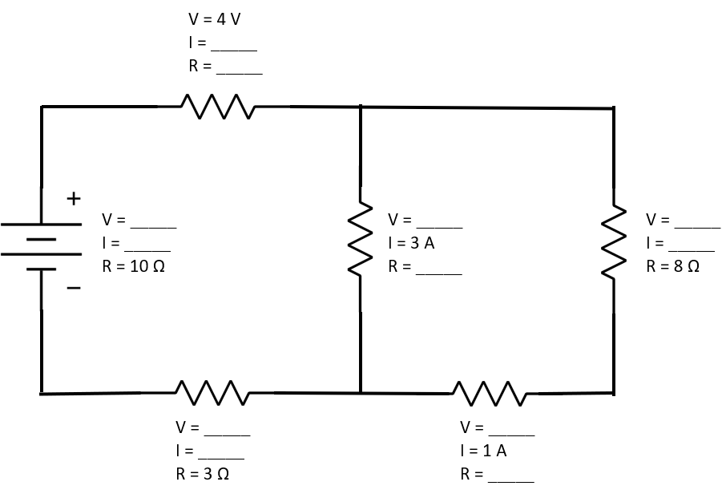
Complete the circuit breakdown by filling in the blanks below. Be sure to include appropriate units.

Extra Credit (2 Points):
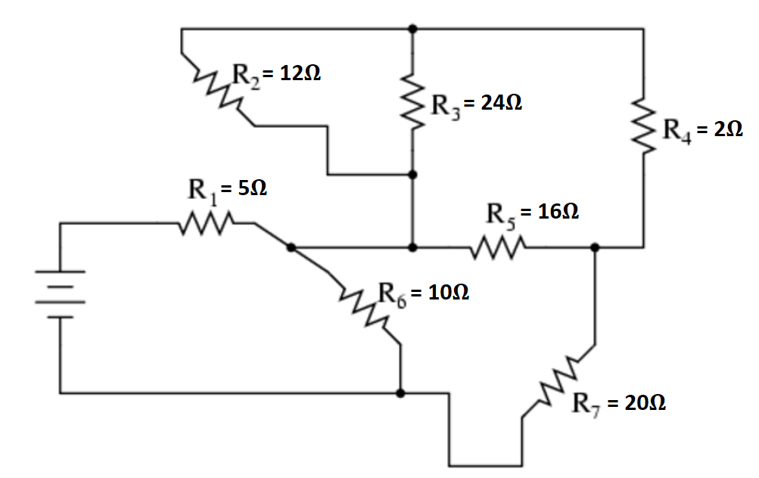
Determine the equivalent resistance (R_{EQ}) of the following circuit.

